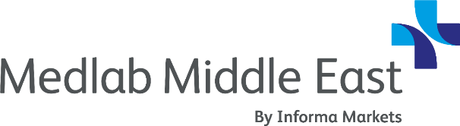

Request For Approval
3–6 February 2020 | Dubai, UAE

Dear [Approving Manager],

I’d like to request your approval to attend the Medlab Middle East Congress happening this 3 – 6 February 2020 at the Dubai World Trade Centre in Dubai, UAE.

This exclusive event provides our organisation with the opportunity to learn from leading industry experts about the latest innovations and technologies in the medical laboratory space.

I can also:
- Earn up to 31.25 CME points – 12 CME accredited conferences
- Learn from more than 120 speakers – 70 international / 50 UAE
- Network with over 25,800 attendees from the lab community
- Explore products from 600+ international suppliers

For more information, visit their website.

I believe this is the one event in 2020 that we do not want to miss. Here’s a list of sessions I’d like to listen to, as I feel the return on my time investment would be twofold:

- Session Title; Speaker Name, Job Title, Organisation
- Session Title; Speaker Name, Job Title, Organisation
- Session Title; Speaker Name, Job Title, Organisation
- Session Title; Speaker Name, Job Title, Organisation
- Session Title; Speaker Name, Job Title, Organisation

I would also like to take this opportunity to review the materials with you and discuss how we can best leverage my time at the event.

Thank you for considering my request. I look forward to discussing the event in further detail.

Sincerely,

[NAME]

